Muhammad Iqbal Raamadhan
Class TI/2I
Number 18
3.1 Experiment Activity 1 In this activity, we would demonstrate about how creating class, creating object, then accessing method in the class. 1. Open NetBeans, create project BikeDemo. 2. Create class Sepeda. Right click on the package BikeDemo – New – Java Class. 3. Type this code in class Bike.
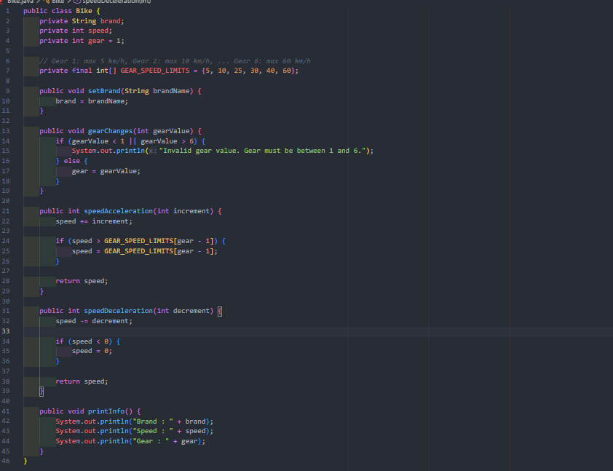
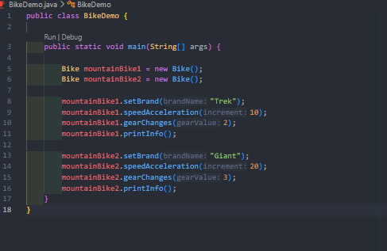
Result

3.2 Experiment 2 In this activity, we would demonstrate inheritance. We perform this inheritance technique by creating class RoadBike which is inherited from class Bike. Basically, class RoadBike I similar with class Bike but it has tire width state. By doing this, we may not creating class RoadBike from the scratch, it just inherits from class Bike to class RoadBike. More detail explanation about inheritance will be discussed in the next module. 1. Still in the project BikeDemo. Create a class named RoadBike. 2. Add a code extends Bike at the class RoadBike declaration. This extends points that class RoadBike inherits class Bike.
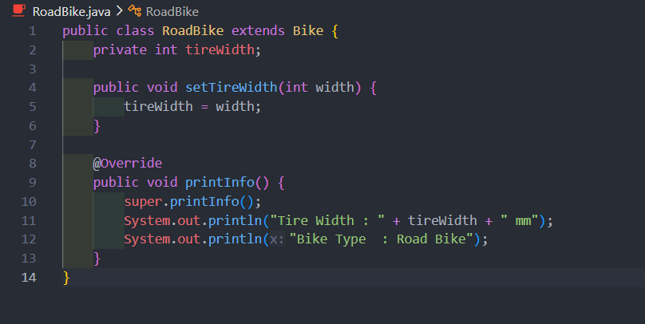
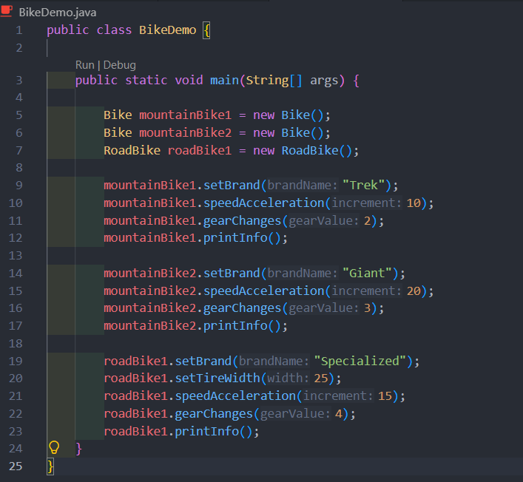
Result
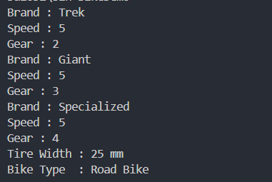

A. Question Test
1. Difference Between Object and Class
- Class: A blueprint, template, or abstract design that defines the structure (attributes) and behavior (methods) of a group of objects. A class does not occupy memory space for actual data.
- Object: A real instance created from a Class that resides in computer memory and holds specific data/values for its attributes.
2. Reason Why Gear and Brand Are Attributes for a Bike Object
- Brand and Gear represent properties, states, or physical characteristics of a bicycle. Since they store data rather than performing actions or behaviors, they are classified as attributes.
3. Advantage of OOP Over Procedural Programming
- Code Reusability & Maintainability: Through concepts like Inheritance and Encapsulation, existing code can be reused and extended without writing it from scratch, making large-scale software development and maintenance significantly easier.
4. Is "public String name, address;" Allowed?
- Yes, it is allowed. In Java syntax, multiple variables sharing the same data type (String) and access modifier (public) can be declared on a single line separated by commas (,).
5. Reason Why Brand, Speed, and Gear Are Not Written Again in RoadBike Class
- The RoadBike class applies Inheritance by extending its parent class (e.g., the Bike class). Consequently, RoadBike automatically inherits all non-private attributes from the parent class without needing to redefine them.

B. Practical Assignment
1. Object Observation
- Inheritance Objects (Parent Class: Electronics):
  - Laptop (Inherits from Electronics)
  - Smartphone (Inherits from Electronics)
- Independent Objects (Non-Inheritance): 3. WallClock 4. WaterBottle

